



MICROSOFT ARCHITECTURE BEST PRACTICE FOR SECURITY
USECASE: AUTOMATED THREAT RESPONSE USING MICROSOFT SENTINEL
Document Title | AUTOMATED THREAT RESPONSE USING MICROSOFT SENTINEL
Presales/Technical Head | Tushar Mehrotra/Rohit Pandey
CCoE Lead | Ravishankar N
Creation Date | November 2025
Version | Description | Modified by | Date | Approved by | Date
1 | Initial Architecture design | AJEET KUMAR | 07/11/2025 | Ravi Shankar | 07/11/2025
2 | Reusability & scalability | AJEET KUMAR | 11/11/2025 | Ravi Shankar | 11/11/2025
3 | Architecture best practices | AJEET KUMAR | 17/11/2025 | Ravi Shankar | 17/11/2025

Contents
1
1. Executive Summary 3
2. Scope and Applicability 3
3. Business Scenario Overview 3
4. Reference Architecture Overview 3
4.1 Architecture Description 4
5. Logical Architecture Components 4
5.1 Microsoft Sentinel SIEM Layer 4
5.2 Data Ingestion and Analytics Layer 4
5.3 Automation Rules Layer 5
5.4 Playbooks and SOAR Layer 5
5.5 Identity and Access Integration 5
5.6 Monitoring and Governance Controls 5
6. Architectural Best Practices 5
7. Cloud Center of Excellence (CCoE) Enablement Model 5
8. Reusability and Scalability 6
9. Conclusion 6

1. Executive Summary
This document is based on automated threat response using Microsoft Sentinel. The solution enables organizations to centrally detect, investigate, and automatically respond to security incidents using Security Information and Event Management (SIEM) and Security Orchestration, Automation, and Response (SOAR) capabilities.
Microsoft Sentinel leverages analytics rules, automation rules, and Logic App–based playbooks to orchestrate rapid and consistent responses to security threats, reducing manual effort and improving security operations efficiency.

2. Scope and Applicability
This reference architecture applies to:
- Enterprise Security Operations Centers (SOC)
- Cloud-scale SIEM and SOAR implementations
- Automated incident response and remediation scenarios
- Microsoft Sentinel deployments in Azure or Microsoft Defender portal
- CSP, enterprise IT, and CCoE-governed environments
The architecture focuses on improving speed, consistency, and accuracy of threat response through automation.

3. Business Scenario Overview
Modern SOC teams face a high volume of security alerts that can overwhelm analysts and delay incident response. Manual investigation and remediation increase mean time to respond (MTTR) and expose organizations to extended attack windows.
Microsoft Sentinel automated response capabilities address this challenge by enabling:
- Immediate response to high-confidence threats
- Automated containment and remediation actions
- Consistent execution of security procedures
This architecture provides a standardized approach for implementing automated security responses at scale.

4. Reference Architecture Overview

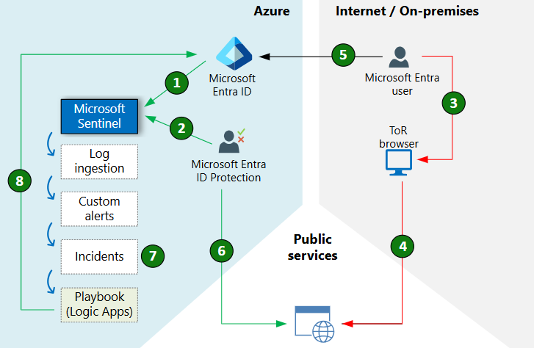

4.1 Architecture Description
The solution implements an event-driven automation architecture where security alerts and incidents detected by Microsoft Sentinel trigger predefined automation rules and playbooks. These workflows execute remediation actions across identity, endpoint, and collaboration services.
Automation is designed to be controlled, able, and aligned with enterprise security policies.

5. Logical Architecture Components

5.1 Microsoft Sentinel SIEM Layer
- Microsoft Sentinel as the centralized SIEM and SOAR platform
- Log Analytics workspace for security data analytics
- Native integration with Microsoft Defender services
This layer provides detection, investigation, and incident management capabilities.

5.2 Data Ingestion and Analytics Layer
- Built-in connectors for Microsoft Entra ID, Microsoft Defender, Azure resources, and third-party sources
- Analytics rules to generate alerts and incidents
- Advanced threat detection and hunting queries
This layer enables real-time security insight generation.

5.3 Automation Rules Layer
- Automation rules to triage, assign, prioritize, and enrich incidents
- Conditional execution based on severity, entities, or incident properties
- Centralized orchestration of multiple playbooks
Automation rules ensure consistent incident handling workflows.

5.4 Playbooks and SOAR Layer
- Azure Logic Apps–based playbooks
- Prebuilt and custom workflows for automated response
- Integration with Microsoft Teams, ServiceNow, email systems, and security tools
Playbooks execute actions such as blocking users, isolating devices, and notifying responders.

5.5 Identity and Access Integration
- Microsoft Entra ID integration for identity-based response actions
- Privileged access controls for automation execution
- Secure authentication for Logic App connectors
Identity integration enables rapid containment of compromised accounts.

5.6 Monitoring and Governance Controls
- Activity logging and trails for all automated actions
- Role-based access control (RBAC) for Sentinel and Logic Apps
- Continuous monitoring and alerting
Governance controls ensure automation remains compliant and able.

6. Architectural Best Practices
This architecture aligns with the Azure Well-Architected Framework, particularly:
- Security – Automated containment and response
- Operational Excellence – Reduced manual effort and faster MTTR
- Reliability – Consistent and repeatable remediation workflows
Automation is implemented incrementally to balance speed and risk.

7. Cloud Center of Excellence (CCoE) Enablement Model
The Cloud Center of Excellence uses this architecture to:
- Define approved automated response patterns
- Govern playbook usage and permissions
- Standardize SOC processes across environments
This enables secure, scalable, and consistent automation across the organization.

8. Reusability and Scalability
- Reusable across multiple threat scenarios and environments
- Scales to enterprise-level SOC operations
- Integrates with Microsoft Defender and third-party security platforms

9. Conclusion
The Microsoft Sentinel Automated Response Reference Architecture provides a Microsoft-aligned framework for implementing SOAR capabilities at scale. By combining analytics, automation rules, and playbooks, organizations can significantly improve threat response speed, consistency, and operational effectiveness.

